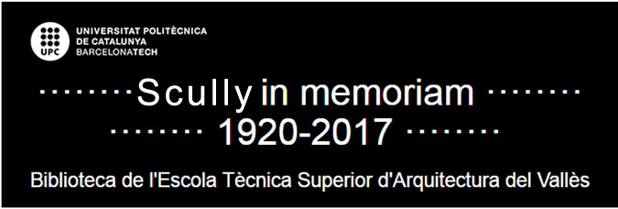

**Bibliography of Vicent Scully from other libraries**

[PINNELL, Patrick](http://search.library.yale.edu/catalog?f%5Bauthor_facet%5D%5B%5D=Pinnell%2C+Patrick%2C+1949-) (1999). *Yale University : The Campus Guide*. Nova York : Princeton Architectural Press. [COAC]

SCULLY, Vincent (1969). Frank Lloyd Wright and Twentieth-Century Style. A: SPENCER, Harold (ed). *Readings in Arts History : 2. The Renaissance to the Present*. Nova York : Scribner. [UAB Humanitats 7(091)Rea V.2]

SCULLY, Vincent (1972). Men and Nature in Pueblo Architecture. A: *American Indian Art: Form and Tradition.* Minneapolis: Walker Art Center. [MNAC]

SCULLY, Vincent (1977). Introducció. A: PUPPI, Lionello. *The Villa Badoer at Fratta Polesine*. Londres: Architectural Press, 1977. [UB GEOGRAFIA EN ITALIÀ]

SCULLY, Vincent (1982). Henry-Russell Hitchcock and the New Tradition. A: SEARING, Helen (ed). *In Search of Modern Architecture: A Tribute to Henry-Russell Hitchcock.* NovaYork i Cambridge : Architectural History Foundation i MIT Press. [UAB HUMANITATS 7.035/.036-72 In]

SCULLY, Vincent (1988). Introducció. A: VIGNELLI, Massimo (ed). *Hugh Newell Jacobsen, Architect.* Washington, D.C.: The American Institute of Architects Press, 1988. [COAC]

SCULLY, Vincent (1999). America at the Millennium : Architecture and Community. A: *The Pritzker Architecture Prize 1998 : Celebrating the Twentieth Anniversary of the Prize : Presented to Renzo Piano*. Los Angeles : Hyatt Foundation i Jensen & Walker. [MUSEU DEL DISSENY DE BARCELONA]

[STERN, Robert A. M (2007).](http://search.library.yale.edu/catalog?f%5Bauthor_facet%5D%5B%5D=Stern%2C+Robert+A.+M.) *Robert A.M. Stern : buildings and towns.* Nova York : Monacelli Press. [COAC TARRAGONA]